YEAR 10 SCIENCE
EARTH AND BEYOND
RESEARCH ACTIVITY

Due Date: Thursday 7th May

Task

Given below are a series of questions aimed at understanding more about the universe, our galaxy and solar system. You need to research information on each question. Record your information in a suitable format - dot point, brief notes, labelled diagram, etc. You will be tested on some or all of these questions, so be well prepared!

Internet Resources

You may find the following websites useful. There are many others as well - remember to select sites that are "reputable". e.g. Well known universities, astronomical societies, NASA, etc.

Metacrawler - a meta-search engine that looks in all other search engines.

http://www.metacrawler.com/

Trinity College Astronomy - very good links to many sites.

http://observatory.trinity.wa.edu.au/index.html

NASA - superb site for up to date information. Many good links as well.

http://www.nasa.gov/home/

Wikipedia - has useful information and good links on near-Earth asteroids.

http://en.wikipedia.org/wiki/Near-Earth_asteroid
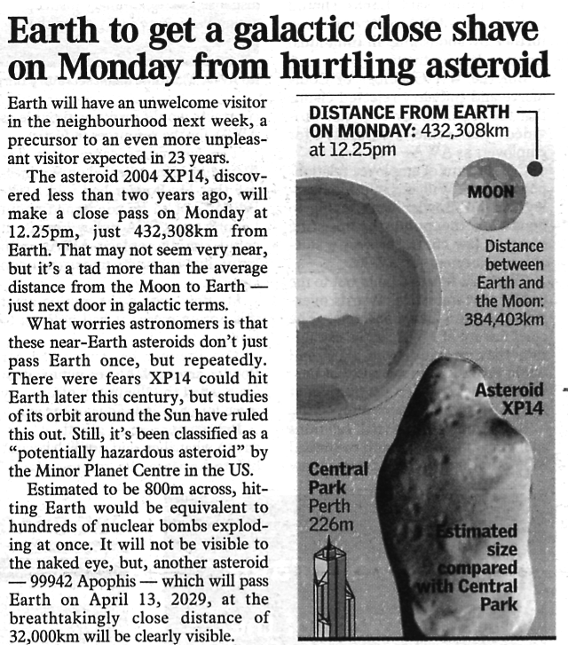
Questions

1. Earth had a near miss with a large asteroid on Monday 3/7/06 at 12.25 pm (Perth time). The article above
appeared in The West Australian newspaper. Astronomers are currently tracking many such objects, each on a
near-Earth orbit.

(a) Name 3-5 projects looking for near-earth asteroids.

(b) There are 3 main types of near-Earth objects - what are they and how do they differ? (Hint: they all begin with the letter ‘A’)

(i)

(ii)

(iii)

(c) How many asteroids and objects are being tracked currently?

(d) Apart from the instance given in the article above, have there been any "close shaves" with objects just missing the Earth? Give data such as date, time, size, speed, distance away. (YOU NEED TO ACTUALLY LOOK FOR ALL THIS INFORMATION… it is on the NASA site… Hint: blue hyperlinks)

DATE | TIME | SIZE | SPEED | MISS DISTANCE

(e) Are we in danger from a collision in the near future? What do the experts and agencies predict?

2. (a) From where do asteroids and meteors come in our solar system?

(b) Why do they orbit so close to the Earth and other planets?

3. In Earth's recent history (50-300 million years), the surface has been hit by asteroids and meteors of varying size.

(a) List one impact that has occurred.

(b) Where and when did it occur?

(c) What was the size of the impact - usually given in equivalent units to nuclear bombs?

(d) What effects did it have? Was life in that area affected? Was there a worldwide effect?

•

•

•

•

•

(e) What evidence currently exists that indicates that the impact occurred?
e.g. Crater above ground or below sea, photographs from space, ground radar, etc.

4. There are competing theories on the origins of the universe - Creation, Steady State, Big Bang and Big Crunch
(Oscillating). Using only a few dot points for each, describe how each theory describes the formation and
evolution of the universe.

Creation

•

•

•

•

Steady State (Infinite Universe Theory)

•

•

•

•

Big Bang

•

•

•

•

Big Crunch (Oscillating)

•

•

•

•

More Useful Sites

http://www.aerospaceguide.net/nearearthasteroids.html

http://neo.jpl.nasa.gov/orbits/

http://impact.arc.nasa.gov/

http://whyfiles.org/106asteroid/2.html

http://sci.uncletom2000.com/creation.htm

http://en.wikipedia.org/wiki/Ultimate_fate_of_the_universe - Big_Crunch:_finite_time_and_lifespan

http://www.pbs.org/wgbh/evolution/extinction/dinosaurs/asteroid.html

Extra Notes
ANSWERS

The following information gives a good guide to the type of information that should have been found by the students.

1 (a) Some main projects looking for near-Earth objects (NEO's).

• LINEAR (Lincoln Near-Earth Asteroid Research)
• Found most objects since 1998 (~ 70%).

• Spacewatch
• University of Arizona.
• Specialises in asteroids and comets.

• NEAT (Near Earth Asteroid Tracking)
• Run by NASA and the Jet Propulsion Laboratory.
• Started 1995.

• LONEOS (Lowell Observatory Near-Earth Object Search).
• Run by NASA and Lowell Observatory (Arizona).

• Japanese Spaceguard Association.
• Tracks near-Earth objects and debris in orbit.

(b) Near-Earth Objects

• Atens - orbit < 1 AU (distance to the Sun); usually orbit inside Earth's orbit.

• Apollos - orbit > Earth's orbit.

• Amors - orbit between Earth and Mars; cross the orbit of Mars but not Earth.

Atens and Apollos cross the Earth's orbit so they pose the greatest threat.

(c) Best estimates.

• NASA - list at least 800 on their website.

• Wikipedia - 3716 (57 comets, 3659 asteroids, 301 Atens, 1433 Amors, 1920 Apollos, 811 NEA's
are > 1 km across).

(d) Recent near-misses.

• March 18, 2004
• Asteroid 2004 FH missed by 43,000 km.
• 30 m in diameter and travelling at 32 km/sec.
• Not big enough to cause a global catastrophe.

• March 31, 2004
• Meteoroid 2004 FU162 missed by 6, 500 km.
• <10 m across.
• Detected only hours before close pass.
• Will disintegrate in the atmosphere.

(e) Torino Scale
• Runs from 1-10.
• Highest rating given so far is 4 (99942 Apophis - a 400 m asteroid).
• Level 4 is 1% chance of collision capable of regional devastation.

2. (a) Asteroids
• Come from the asteroid belt between Mars and Jupiter.
• Used to be thought of as an exploded planet.
• Not possible - there isn't enough mass present in all the asteroids.
• Now thought to be a planet that didn't form properly.

(b) • Jupiter exerts a strong gravitational pull on the asteroids.
• Pulls them into orbits that come close to Earth and the other inner planets.

3. (a) Earth Impacts

• June 6, 2002
• 10 m wide object detonated in the air over the Mediterranean Sea.

• June 30, 1908
• Tunguska (Russia) 7.15 am.
• Explosion 6-8 km above the ground.
• Flattened 60 million trees over an area of 2150 km².
• Seen as a brilliant flash of light from 50 km around.

• 49,000 years ago
• Barringer Crater (Arizona).
• Meteor moving at 11 km/sec.

• 65 million years ago
• K-T Event.
• > 10 km wide asteroid.
• Yucatan region Mexico (Chixulub - 170 km across)
• Caused 70 % extinction of life on Earth.
• Iridium found in the surrounding rock could only have come from an asteroid.
• Dust in the air reduced sunlight and lowered temperatures for months.
• Thought to have generated 650 m high tsunami waves.

4. Creation
• All material in the universe was created by God or a divine entity.
• Explains how everything came into existence from the first point in time - other theories can't do this.

Big Bang
• Universe began from a singularity (single point of space and time).
• Occurred 13.7 billion years ago.
• Space is observed to be continually expanding - galaxies show a red shift in their light (Doppler Effect).
• There are some problems with this theory but is generally sound in describing the universe.

Big Crunch
• Universe undergoes an infinite series of oscillations - starts with a big bang and ends with a big crunch.
• Gravity slows down the expansion after the big bang.
• Universe then contracts and collapses back in on itself to a singularity - a big crunch.
• This theory also has problems - measurements show that the universe is not closed.

Steady State
• Known as the Infinite Universe Theory of Continuous Creation.
• Even though the universe is expanding, it doesn't change its look over time.
⇒ Nothing new is created.
• Not as well supported now.
• Has problems - new material is being made in the universe.

Most astronomers consider the Big Bang Theory as the best description of the origin of the universe.

